Entry Form  BEST VISIBILITY AT POINT OF PURCHASE  Category: B7 |  | 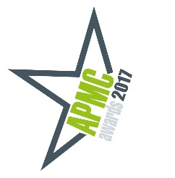
ENTRY DETAILS  CATEGORY CODE:  CATEGORY NAME:  NAME OF CLIENT COMPANY:  BRAND:  CLIENT CONTACT:  TITLE:  NAME OF CAMPAIGN/EXECUTION:  PERIOD OF IMPLEMENTATION: FROM: TO:  Remember that campaigns must have ended by December 31st 2016 (other than for the Long-Term Campaign Category)  TARGET AUDIENCE:  INDUSTRY CATEGORY ENTERED: |  | ENTRY ID CODE  APMC USE ONLY
PLEASE DEMONSTRATE HOW INNOVATION IN VISIBILITY AT POINT OF PURCHASE IMPACTED ON THIS PROMOTION

OBJECTIVES:
List specific objectives in order of importance. Please complete in 150 words or fewer.

RESULTS:
Remember that vague results may lead to poor marks. Include results that indicate how innovative the use of Visibility at Point of Purchase was – you can include results other than sales. Please complete in 150 words or fewer.

BUDGET FOR THE CAMPAIGN:

BACKGROUND TO THE CAMPAIGN – IF NOT ALREADY ENTERED INTO AN INDUSTRY CATEGORY:
If you have already entered this campaign into an industry category, the judges will be familiar with the background and it may not be necessary to complete this section.

REMARKS:

CLIENT APPROVAL FORM  One copy only per entry – for APMC USE  TECHNIQUE CATEOGRIES  B7 Best Visibility at Point of Purchase |  |  |  | 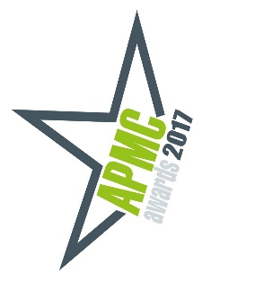
CLIENT APPROVAL FORM – ONE COPY PER ENTRY ONLY PLEASE – THIS WILL NOT BE SEEN BY THE JUDGING PANEL AND IS FOR APMC RECORDS ONLY.

Please note that the information contained in this APMC Awards Entry Form is confidential and will be seen only by the judges. The forms will be destroyed once judging has taken place and no results will be released in any publicity materials or presentations relating to the awards.

NAME OF PROMOTION
AGENCY
CLIENT COMPANY NAME
CONTACT NAME
TITLE
CLIENT ADDRESS
TELEPHONE |  | EMAIL
I confirm that I approve the entry of the above named promotional campaign into the 2017 APMC Star Awards. I confirm that all the information supplied in this entry is true and has been approved by me.
SIGNATURE
ON BEHALF OF (CLIENT COMPANY NAME)

APMC AWARDS 2017 CHECK LIST

Before you submit your entry, please check the following:

- Ensure that the name of the submitting agency is not referred to on the entry forms, creative boards, video or other material that the judges will see. Failure to adhere to this anonymity measure may result in your entry being invalidated.

- No more than two A2 boards to be supplied. You must supply separate boards if you are entering a promotion into more than one category. Please note that the boards may be displayed at our awards ceremony and should not include any confidential or sensitive information.

- A USB key with video or audio of your campaign may be submitted where appropriate – MP4 Video format please. One key per entry as these will be viewed by the judges. Please affix your USB key to the back of your entry board. Links to You Tube may also be referenced for the judges to view.

- Five copies of the completed entry form per category being entered. Please note that only one copy of the client approval form need be included.

- Entries must be accompanied by a USB key with a JPEG slide of a single clear image of the creative of each campaign being entered. This may be used in the AV presentation at the Awards ceremony. One USB key containing all your JPEG slides please.

- Entries must be accompanied by a USB key with a 70-word summary for each campaign, 20 words outlining the challenge and 50 words outlining your response to that challenge in a Microsoft Word document. Please also include an EPS image of each campaign and your agency logo. Nominated campaigns will be eligible for publication in our annual Star Awards book. Again, only one USB key per agency with all your summaries and EPS images please.

- Completed Client Approval Form - one copy per campaign only please.

- Ensure that entry is noted on the Summary Control Sheet.

- Entry Fees must be included: Agency Members €95 & 23% VAT per entry; Partner Members €195 & 23% VAT per entry; Non-Members €250 & 23% VAT per entry.
- Competition Rules and Terms & Conditions of the promotion being entered must be included.

All enquiries to: Karen Neville (01) 2848401 or karen@apmc.ie or refer to www.apmc.ie/awards

